LOAN MANAGEMENT SYSTEM
@CREATIVITY THINK (9483175986/7019689991)

ABSTRACT:
Loan Management System is a web application designed to streamline the loan lifecycle for banks, microfinance institutions, and cooperative societies. Users can apply for loans, upload required documents, track application status, view payment schedules, and access interactive dashboards. Administrators manage approvals and rejections, monitor payments, analyze loan performance, and generate analytics dashboards. Built with Django and Django Rest Framework for backend operations and React with Redux and Recharts for frontend interfaces, the system provides a centralized, real-time, and user-friendly solution for managing loan applications, approvals, and repayments efficiently..

INTRODUCTION OF THE PROJECT:
Managing loans manually can be inefficient, error-prone, and time-consuming. Loan Management System offers a web-based platform where users can apply for loans, submit documents, track status, and monitor repayments. Administrators manage loan approvals and rejections, oversee payment collections, and generate performance analytics. Using Django for backend services and React with Redux and Recharts for dynamic dashboards, the system ensures accurate loan processing, transparent tracking, and comprehensive management. This platform enhances operational efficiency for financial institutions while providing clear and intuitive dashboards for both users and administrators..

PROJECT OBJECTIVES:

• Provide a centralized platform for loan application and management
• Allow users to apply for loans and upload supporting documents
• Track application status and provide payment schedules
• Automate and streamline loan approval and rejection workflow
• Enable administrators to monitor payments and manage loan performance
• Generate analytics dashboards for loan tracking and decision-making
• Reduce errors and improve transparency in loan management

PROBLEM OF THE STATEMENT:
Financial institutions often face challenges in managing loan applications, approvals, and repayments manually, resulting in delays, errors, and lack of transparency. Loan Management System addresses these issues by providing a centralized web platform that automates the loan lifecycle—from application submission to approval, repayment tracking, and performance reporting. Users can track applications and payment schedules in real time, while administrators gain oversight through dashboards and analytics. This ensures efficient, transparent, and error-free management of loans for both institutions and clients..

MOTIVATION OF THE PROJECT:
• Simplify loan application and approval processes
• Automate tracking of payments and repayment schedules
• Reduce errors in loan processing
• Provide analytics for better decision-making
• Enhance transparency and efficiency for institutions and users

BLOCK DAIGRAM OF PROJECT:

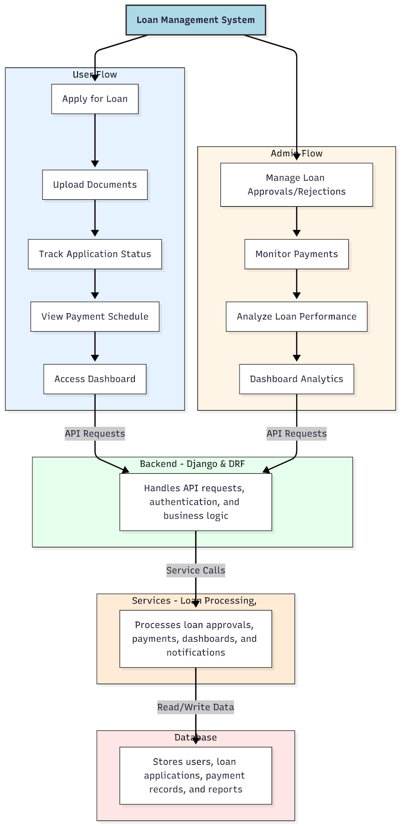

WORKING OF THE PROJECT:
Users apply for loans, upload required documents, track application status, view payment schedules, and access dashboards with real-time updates. The backend manages authentication, API requests, and loan processing logic. The services layer handles loan approval workflows, payment tracking, notifications, and analytics dashboards. Administrators manage approvals and rejections, monitor payments, and analyze loan performance using dashboard analytics. This integrated system ensures accurate, efficient, and transparent management of loan operations for both users and institutions..

SOFTWARE REQUIREMENT:
- Backend:
  - Python 3.x
  - Django
  - Django REST Framework
  - SQLite/PostgreSQL
- Frontend:
  - Node.js and npm
  - React.js
  - Axios
- Development Tools:
  - Visual Studio Code
  - Postman (for testing APIs)
  - Git/GitHub (for version control)
- Server/Deployment (Optional):
  - Gunicorn, Nginx, or Heroku/AWS for hosting

ADVANTAGES OF THE PROJECT:

• Centralized loan lifecycle management
• Automates loan applications and approvals
• Tracks payments and repayment schedules accurately
• Dashboard analytics for performance monitoring
• Reduces errors and delays in processing
• Enhances transparency for users and institutions
• Streamlines administrative operations
• Real-time updates and notifications

APPLICATIONS OF THE PROJECT:
• Banks and financial institutions
• Microfinance organizations
• Cooperative societies
• Loan processing and approvals
• Payment schedule tracking
• Performance analytics for loan portfolios
• Dashboard reporting for administrators
• Customer self-service loan tracking

REFERENCES:

- Django REST Framework Documentation — Django Software Foundation. Django Documentation. Available: https://docs.djangoproject.com/
- Django REST Framework. DRF Documentation. Available: https://www.django-rest-framework.org/
- React. React Official Documentation. Available: https://reactjs.org/docs/getting-started.html
- Redux. Redux Documentation. Available: https://redux.js.org/introduction/getting-started
- PostgreSQL Global Development Group. PostgreSQL Documentation. Available: https://www.postgresql.org/docs/
- MySQL. MySQL Reference Manual. Available: https://dev.mysql.com/doc/
- Git. Git Documentation. Available: https://git-scm.com/doc
- Node.js. Node.js Documentation. Available: https://nodejs.org/en/docs/
- Axios. Axios Documentation. Available: https://axios-http.com/docs/intro
- Socket.io Documentation – https://socket.io/docs/

